1. Strassen Matrix Multiplication
AIM
To implement Strassen's Matrix Multiplication algorithm for multiplying large matrices efficiently using seven recursive multiplications instead of eight.
ALGORITHM
- Read two square matrices A and B.
- If the matrix size is not a power of 2, pad it with zeros.
- Divide each matrix into four submatrices.
- Calculate the seven products M1 to M7.
- Use these products to calculate the four result submatrices.
- Combine the four submatrices to obtain the final matrix.
- Remove any padded rows and columns.
- Verify the result with standard matrix multiplication.
- 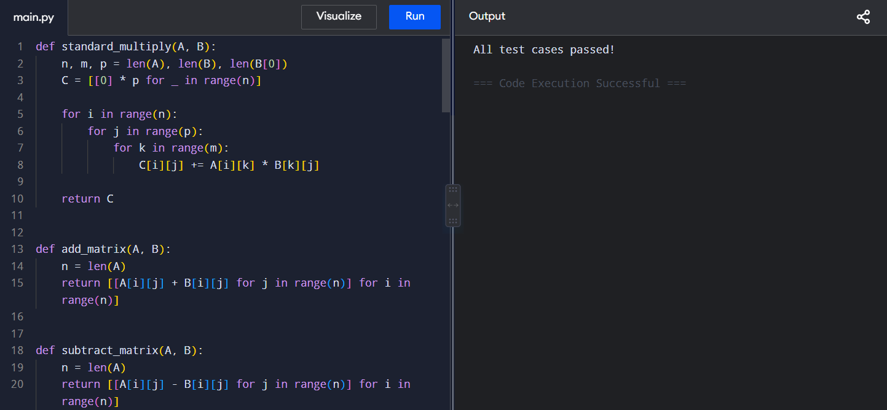
RESULT
Thus, Strassen's algorithm was successfully implemented and verified to produce the same result as standard matrix multiplication.
2. Comparing Multiplication Counts
AIM
To compare the theoretical number of scalar multiplications performed by Strassen's algorithm and standard matrix multiplication.
ALGORITHM
- Read the matrix size n.
- Calculate standard multiplication count as n³.
- Find the next power of 2 greater than or equal to n.
- Let 2^k be the padded size.
- Calculate Strassen multiplication count as 7^k.
- Compare both multiplication counts.
- Display the results and determine when Strassen becomes advantageous.
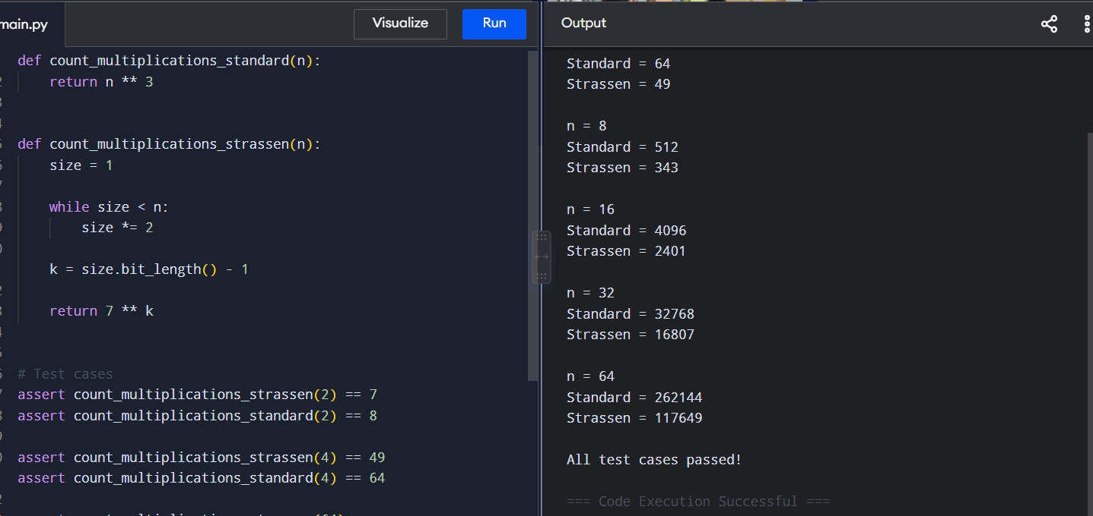
RESULT
Thus, the multiplication counts of Strassen and standard algorithms were successfully calculated and compared. Strassen requires fewer scalar multiplications for sufficiently large matrices.

3. Non-Square / Padded Matrices
AIM
To implement Strassen's algorithm for arbitrary-sized and non-square matrices using zero padding.
ALGORITHM
- Read matrices A and B.
- Check whether their dimensions are compatible.
- Find the maximum dimension among the matrices.
- Find the next power of 2.
- Pad the matrices with zeros to form square matrices.
- Apply recursive Strassen multiplication.
- Trim the extra rows and columns from the result.
- Compare the result with standard multiplication. 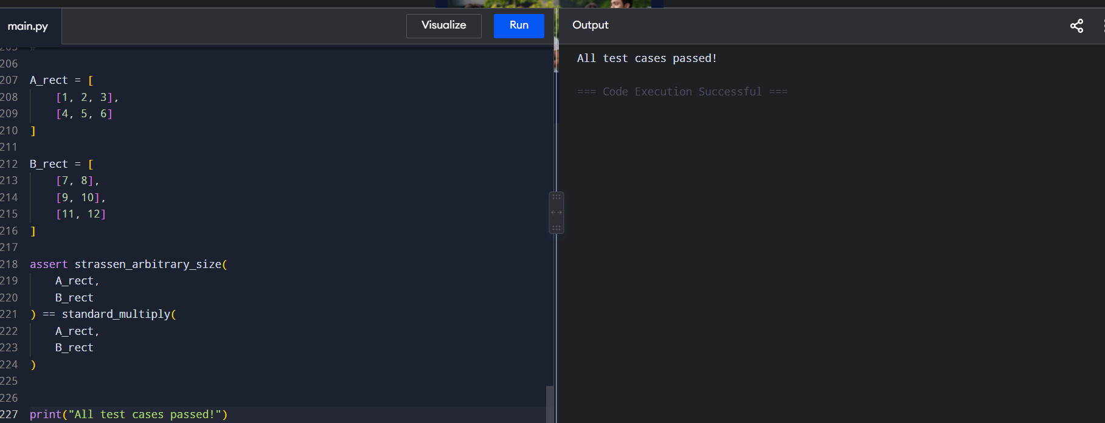
RESULT
Thus, Strassen's algorithm was successfully extended to handle non-square and non-power-of-two matrices.

4. Benchmarking Strassen vs Standard Multiplication
AIM
To compare the practical execution time of Strassen's matrix multiplication with standard triple-loop multiplication.
ALGORITHM
- Generate random square matrices.
- Perform standard matrix multiplication.
- Record its execution time.
- Perform Strassen matrix multiplication.
- Record its execution time.
- Repeat for different matrix sizes.
- Compare the execution times.
- Verify that both algorithms produce the same result. 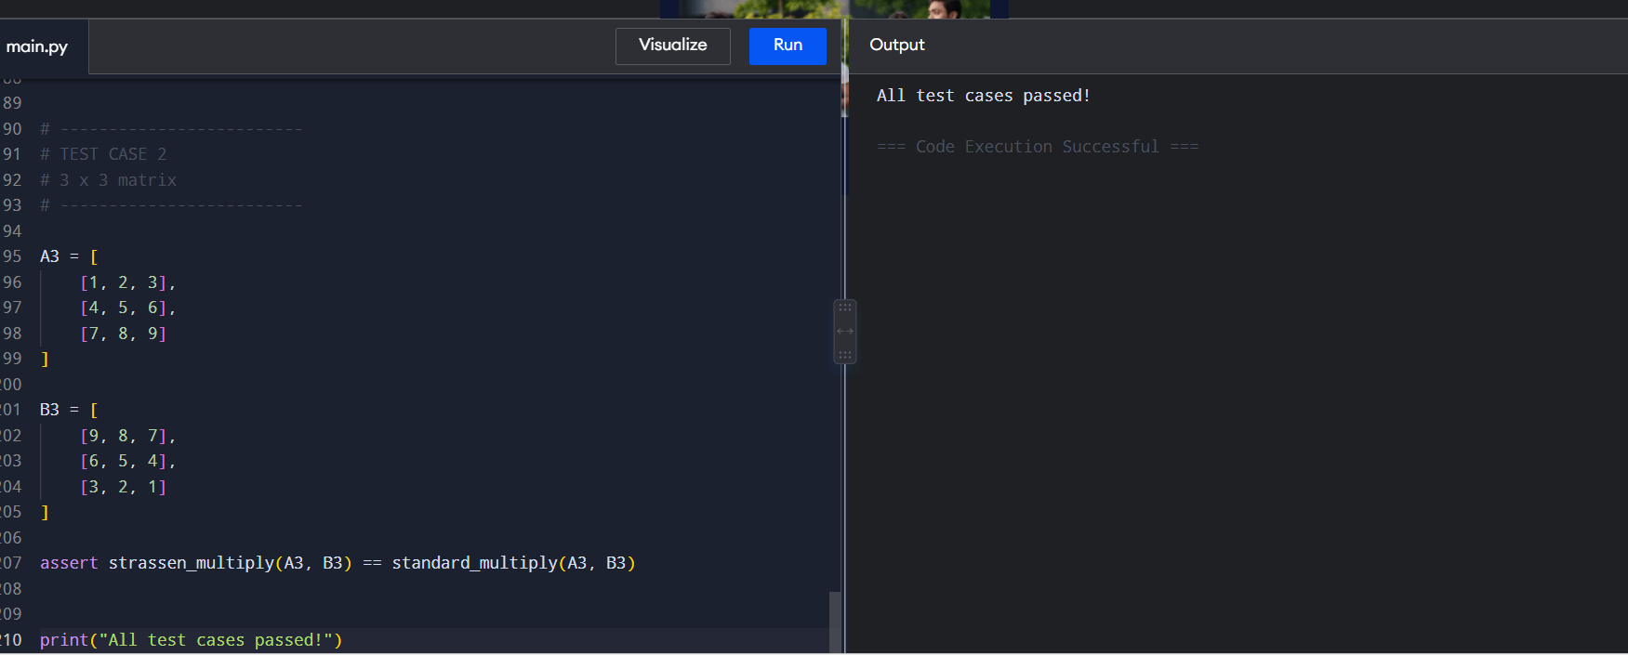
RESULT
Thus, the execution times of standard and Strassen matrix multiplication were successfully measured and compared.

5. Hybrid Strassen with Base Case Tuning
AIM
To implement a hybrid Strassen algorithm that switches to standard multiplication for small matrices to reduce recursive overhead.
ALGORITHM
- Read matrices and define a threshold value.
- Check the current matrix size.
- If the size is less than or equal to the threshold, use standard multiplication.
- Otherwise, divide the matrices into four submatrices.
- Calculate the seven Strassen products recursively.
- Combine the results.
- Verify the hybrid result with standard multiplication.
- Test using different threshold values. 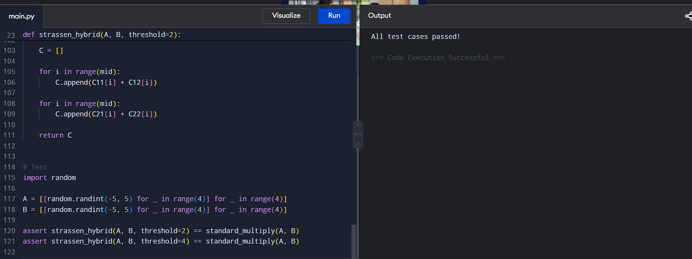
RESULT
Thus, the hybrid Strassen algorithm was successfully implemented and verified, reducing unnecessary recursion for small matrices.

6. Karatsuba Multiplication
AIM
To implement Karatsuba multiplication for efficiently multiplying large integers using three recursive multiplications instead of four.
ALGORITHM
- Read two integers x and y.
- If either number is a single digit, multiply directly.
- Divide each number into high and low halves.
- Calculate z0 using the low halves.
- Calculate z2 using the high halves.
- Calculate z1 using the sums of high and low halves.
- Combine z0, z1, and z2 using positional shifts.
- Return the final product.
- Compare it with normal multiplication. 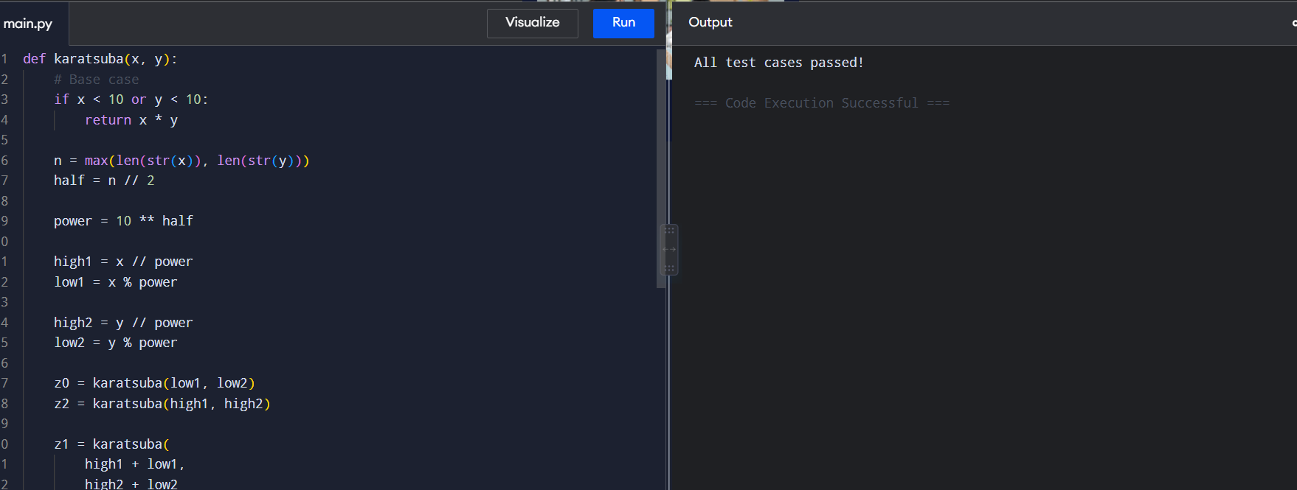
RESULT
Thus, Karatsuba multiplication was successfully implemented and verified for large integers.

7. Arbitrary-Precision Arithmetic
AIM
To compare Karatsuba multiplication with schoolbook multiplication for large arbitrary-precision integers.
ALGORITHM
- Read two large integers.
- Implement schoolbook multiplication using digit manipulation.
- Implement Karatsuba multiplication recursively.
- Multiply the same numbers using both methods.
- Compare their results.
- Repeat for increasing numbers of digits.
- Compare their computational efficiency. 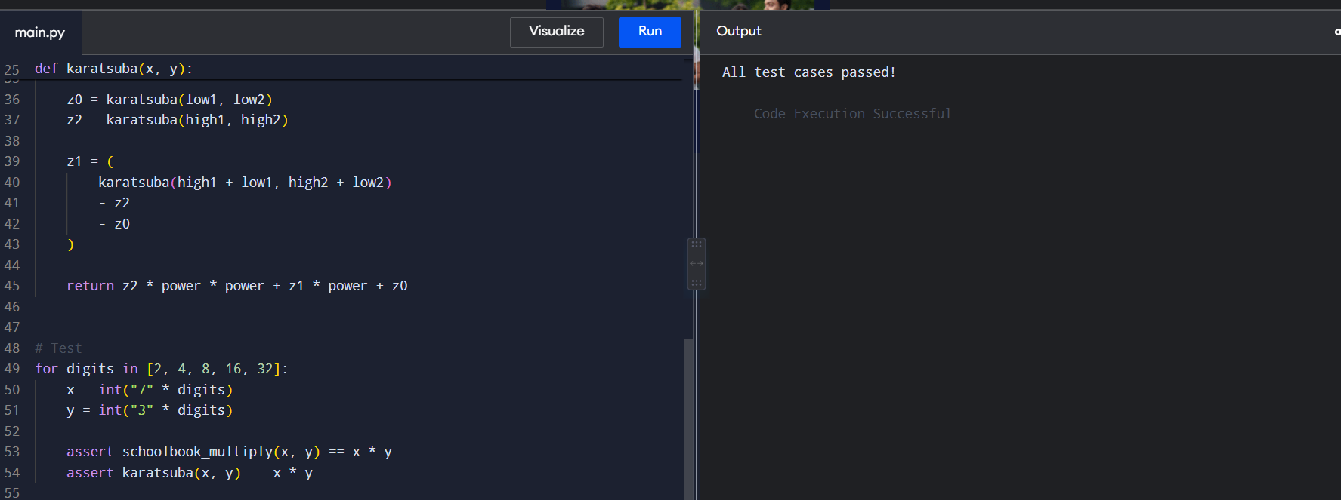
RESULT
Thus, both multiplication methods were successfully implemented and compared, and Karatsuba produced the correct results with better asymptotic complexity for large inputs.

8. Counting Recursive Calls
AIM
To count and analyze the number of recursive calls made by Karatsuba multiplication.
ALGORITHM
- Initialize a counter to zero.
- Increment the counter whenever the Karatsuba function is called.
- Divide the numbers into high and low halves.
- Recursively calculate the three Karatsuba products.
- Continue until the base case is reached.
- Return the multiplication result and recursive call count.
- Compare the call growth with schoolbook multiplication. 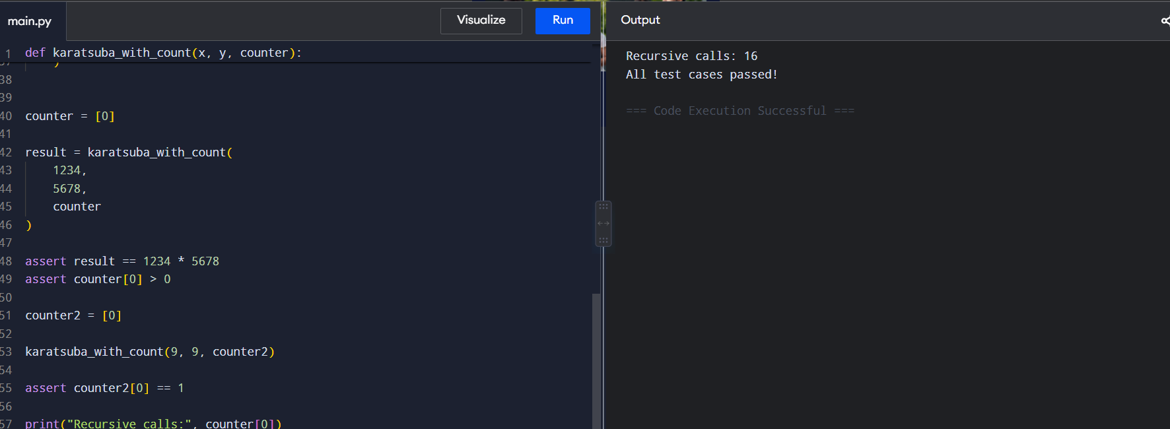
RESULT
Thus, the recursive calls made by Karatsuba multiplication were successfully counted and analyzed.

9. Recursive Split Visualizer
AIM
To implement Karatsuba multiplication while recording each recursive split to represent its recursion tree.
ALGORITHM
- Read two integers.
- Start the Karatsuba recursion.
- Record the current recursion depth.
- Divide each number into high and low halves.
- Store the operands and their corresponding splits.
- Recursively process the three subproblems.
- Combine the results.
- Return the final product along with the recorded trace. 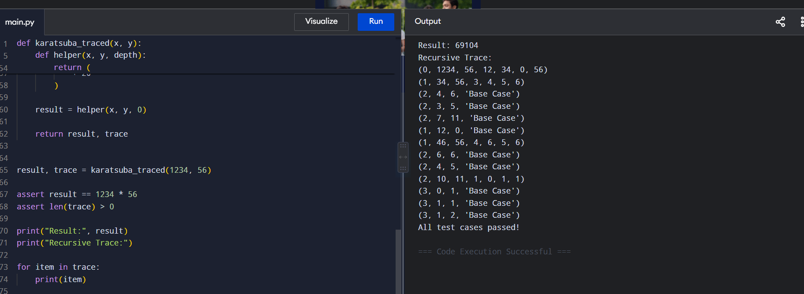
RESULT
Thus, the Karatsuba recursive splits were successfully recorded, providing information that can be used to construct a recursion tree.

10. Polynomial Multiplication
AIM
To implement Karatsuba-style polynomial multiplication using divide-and-conquer to reduce coefficient multiplications.
ALGORITHM
- Read two polynomials as coefficient lists.
- Divide each polynomial into high-degree and low-degree parts.
- Calculate the low-part product.
- Calculate the high-part product.
- Calculate the middle product using the sum of the two parts.
- Subtract the low and high products from the middle product.
- Combine all three products using degree shifts.
- Compare with naive polynomial multiplication. 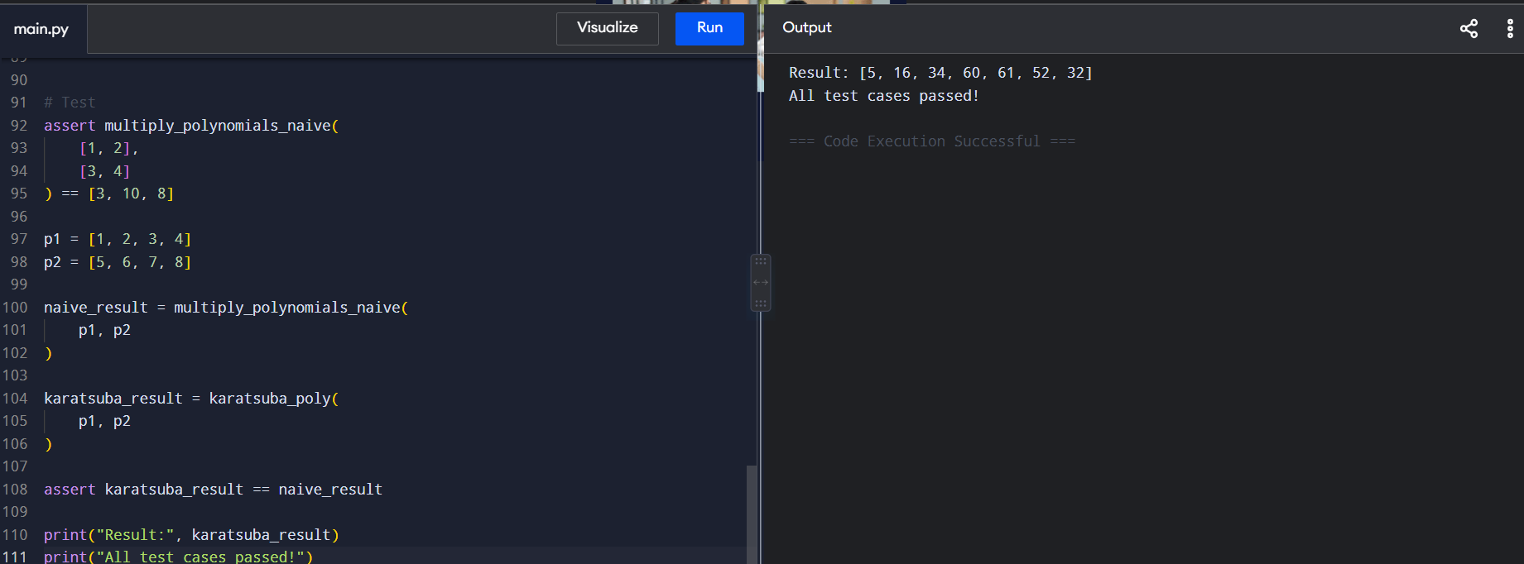
RESULT
Thus, Karatsuba-style polynomial multiplication was successfully implemented and verified against naive polynomial multiplication.

11. Closest Pair of Points
AIM
To find the closest pair of points among a set of points using the divide-and-conquer technique.
ALGORITHM
- Read the coordinates of all points.
- Sort the points according to their x-coordinate.
- Divide the points into two halves.
- Recursively find the closest pair in each half.
- Select the smaller distance.
- Create a vertical strip around the dividing line.
- Sort the strip points according to their y-coordinate.
- Check possible pairs within the strip.
- Return the closest pair and its distance. 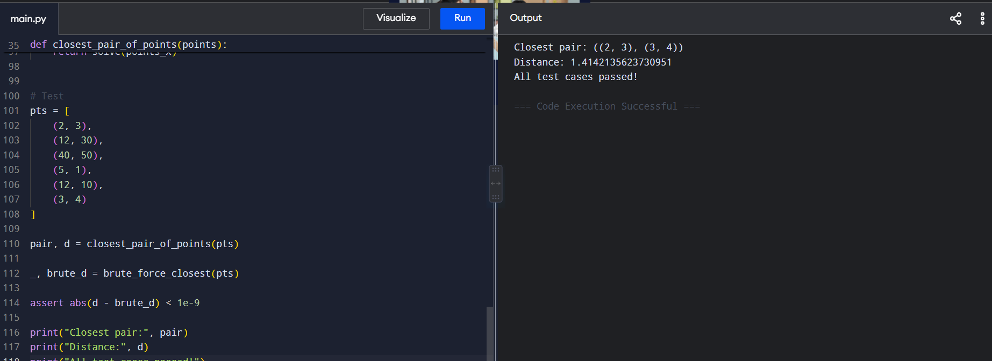
RESULT
Thus, the closest pair of points was successfully identified using the divide-and-conquer algorithm with O(n log n) time complexity.

12. Collision Detection in Game Engine
AIM
To detect potential collisions between objects by finding the minimum distance between their positions using the closest-pair algorithm.
ALGORITHM
- Represent each game object as a 2D coordinate.
- Apply the closest-pair algorithm.
- Find the minimum distance between any two objects.
- Compare the minimum distance with the collision threshold.
- If the distance is less than or equal to the threshold, report a collision.
- Otherwise, report that no collision is detected. 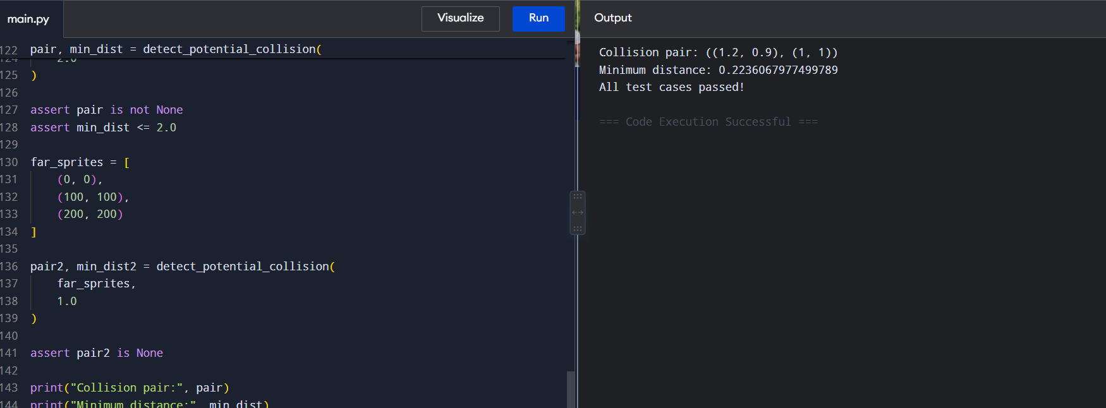
RESULT
Thus, potential collisions between game objects were successfully detected using the closest-pair algorithm.

13. Sensor Node Placement
AIM
To determine whether sensor nodes satisfy the minimum safe distance requirement using the closest-pair algorithm.
ALGORITHM
- Read the coordinates of all sensor nodes.
- Apply the closest-pair divide-and-conquer algorithm.
- Calculate the minimum distance between any two nodes.
- Compare it with the specified minimum safe distance.
- If the distance is smaller, report unsafe placement.
- Otherwise, report safe placement.
- Display the closest pair and minimum distance. 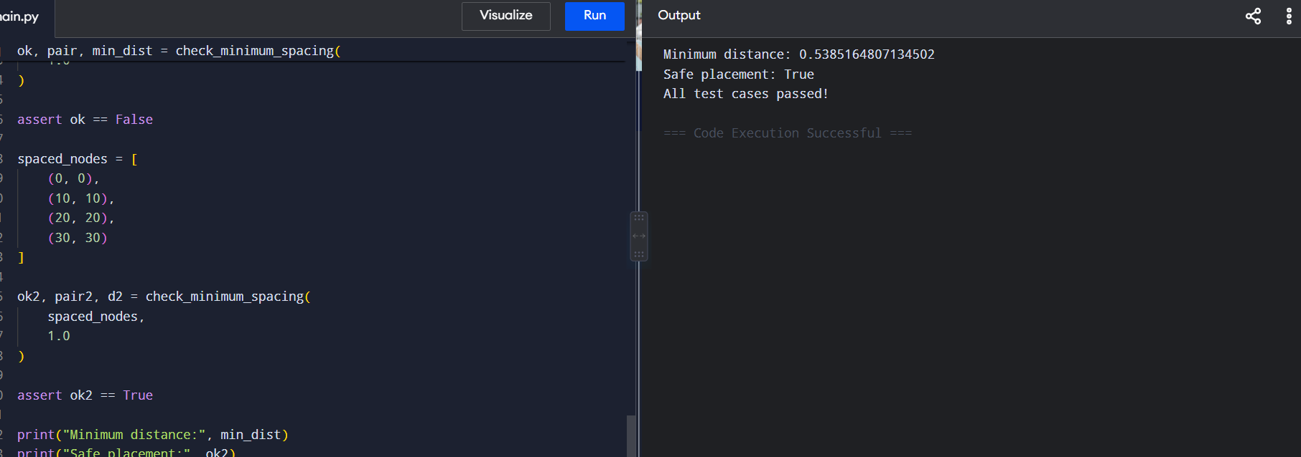
RESULT
Thus, the minimum spacing between sensor nodes was successfully determined and checked against the required safety distance.

14. Median-of-Medians Selection
AIM
To implement the Median-of-Medians selection algorithm to find the kth smallest element with guaranteed linear-time performance.
ALGORITHM
- Read the array and value of k.
- Divide the elements into groups of five.
- Find the median of each group.
- Recursively find the median of these medians.
- Use it as the pivot.
- Partition the array into elements smaller than, equal to, and greater than the pivot.
- Determine which partition contains the kth element.
- Recursively search that partition.
- Return the kth smallest element. 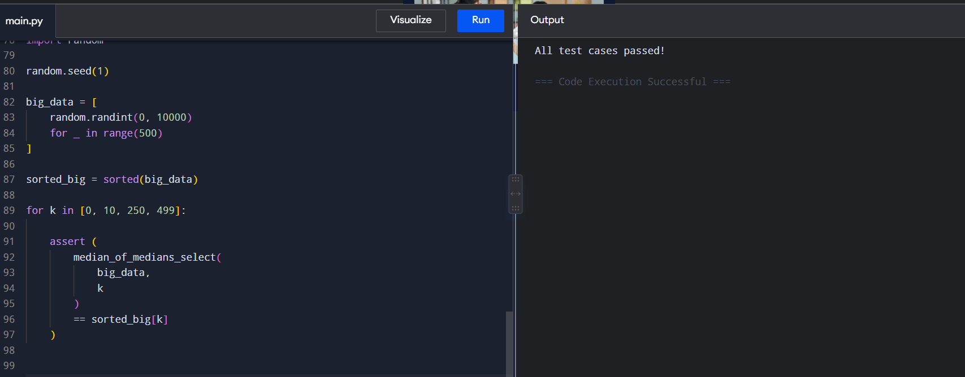
RESULT
Thus, the kth smallest element was successfully found using the Median-of-Medians algorithm with O(n) worst-case time complexity.

15. Kth Fastest Delivery Time
AIM
To find the Kth fastest delivery time using the Median-of-Medians algorithm without completely sorting the delivery-time dataset.
ALGORITHM
- Read the list of delivery times and the value of k.
- Divide the data into groups of five.
- Find the median of each group.
- Find the median of the group medians.
- Use it as the pivot.
- Partition the delivery times into smaller, equal, and larger values.
- Determine the partition containing the kth smallest value.
- Recursively continue the selection.
- Return the kth fastest delivery time. 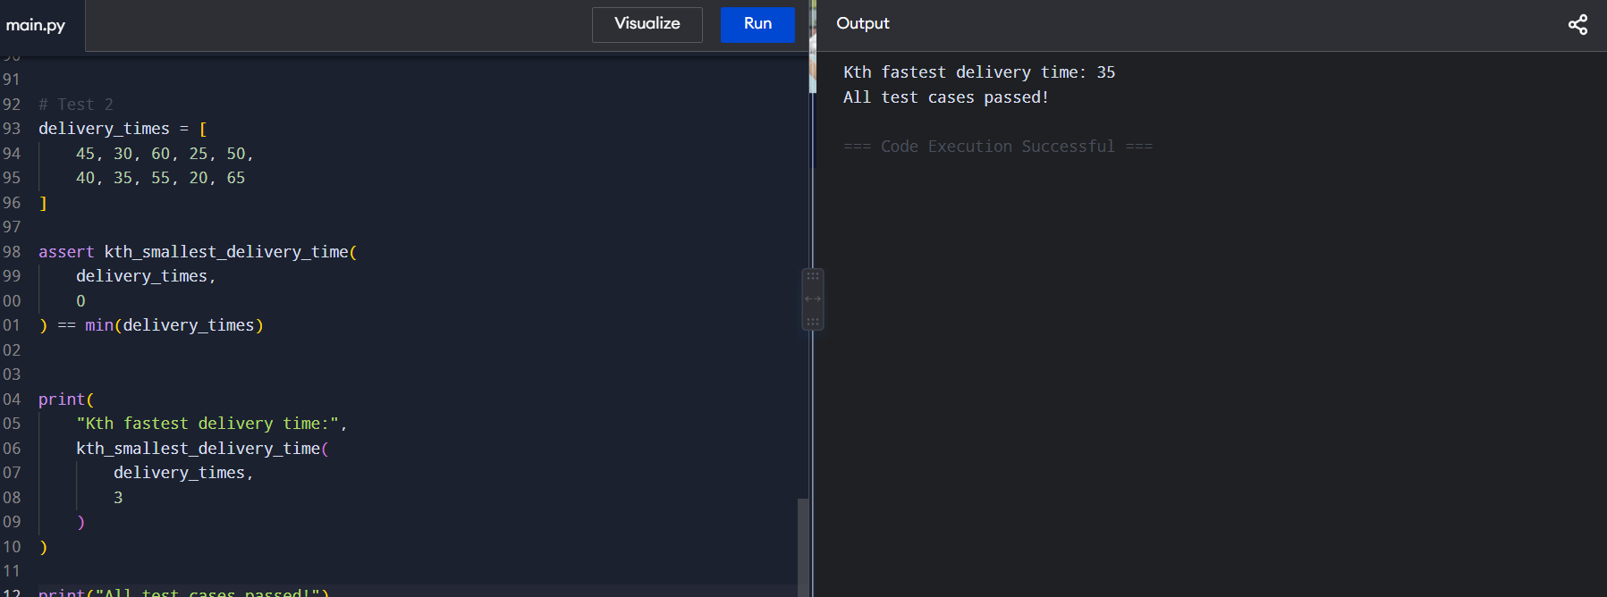
RESULT
Thus, the Kth fastest delivery time was successfully obtained using the Median-of-Medians algorithm with a guaranteed O(n) worst-case time complexity.

